**Evaluation of Required Skills and Competencies in Construction Project Management: Analysis of job advertisement posts for construction project managers to find the most sought-after skills and competencies in the industry, aiding inform training programs and educational curricula**

Assessment 1C

**PPMP20019 – Research Project 1**

*Submitted by:*

PAIR NO. 01

SAMHITHA CHICKBALLAPUR NAGENDRA [12212478]

HARSHIL DIPAKKUMAR PATEL [12208041]

**TABLES OF CONTENTS**

**Executive Summary** 3

**1.** **Introduction** 4

**1.1 Research Questions and Objectives** 5

**2.** **Needs and Significance** 5

**3.** **Summary and Theme Matrix Tables** 9

**4.** **Literature Review** 22

**5.** **Research Methodology** 35

**4.1 Research Design** 35

**4.2 Data Collection** 36

**4.3 Data Extraction** 37

**4.4 Data Analysis** 38

**4.5 Research Outputs** 38

**4.6 Limitations** 39

**4.7 Reporting** 40

**4.8 Ethical Considerations** 41

**6.** **Project Management Implementation Plan** 41

**7.** **Conclusion** 44

**8.** **Limitations** 44

**7.1 Anticipated Results and Implications** 45

**9.** **Statements of Reflection and Contribution from Each Group Member** 45

# **Executive Summary**

Construction project managers are essential to the accomplishment of every construction project, from large-scale infrastructure projects to residential constructions. The work of project managers has expanded in complexity as the construction industry changes because of technical improvements, new market trends, and changed stakeholder expectations. They call for a flexible skill set that combines traditional project management knowledge, technology adaptation, and forward-thinking tactics.

However, academic schools frequently find it difficult to keep up with these changes in the industry, which causes a widening gap between theory and practice. This study examines job postings aimed at construction project managers to determine the most in-demand skills and competencies in the industry to remedy this disconnect. The main goals are to close the knowledge gap between academics and industry, improve education and training programs, and offer insightful information to professionals and construction businesses. Due to the industry's dynamism, it needs a flexible workforce that can handle technological advancements, sustainability requirements, and regulatory changes. Even though academic programs are vital, they might not give graduates the skills they need to succeed in this changing environment. To clarify the intricate requirements of the industry, direct curriculum creation, provide information on career advancement, and have an impact on hiring practices, we analyze job postings. This study promotes industry-education cooperation, guaranteeing that graduates have both theoretical understanding and practical skills, which benefits both students and the construction industry. The vitality of the construction sector, the growing divide between academics and business, the necessity of matching educational objectives to business requirements, the detection of new business trends, and the broad-reaching ramifications of this research are all topics covered in this proposal. In this in-depth analysis, we present a holistic view of the developing discipline of construction project management and its potential to alter all involved parties.

# **Introduction**

Every project's success in the field of construction project management depends on the skill and competency of the project managers. These experts oversee coordinating the proper design, implementation, and completion of construction projects, ranging from complex residential developments to massive infrastructure projects. The function of construction project managers goes beyond traditional project monitoring as the industry continues to change because of technical breakthroughs, shifting market trends, and changing stakeholder expectations. Construction project managers today need to have a versatile skill set that can adapt to the industry's constantly shifting needs (Garousi et al., 2019). They must traverse a complicated environment that includes regulatory compliance, sustainability norms, and the ubiquitous effect of digitalization in addition to the fundamental concepts of project management. Their skill set is important not only for finishing projects on schedule and under budget, but also for following safety requirements, using sustainable construction methods, and utilizing cutting-edge technologies (Posillico, 2023). The key is to match the education and training programs provided to prospective construction project managers with the changing needs of the sector. While academic programs teach vital project management skills, they must constantly change to keep up with the quick changes seen in the construction industry. The current disconnect between theoretical understanding and actual industry requirements highlights the urgent need for a thorough examination of the skills and competencies that are crucial to the sector (Lopushniak et al., 2022). By offering useful insights into the abilities and competencies that employers in the construction project management sector value most highly, this research Endeavor aims to close this knowledge gap. Our main goal is to identify the most sought-after talents, abilities, and certifications in this dynamic field by a careful analysis of job adverts aimed at construction project managers. Beyond its consequences for academia, this study project has major ramifications for educational institutions, business experts, and construction companies.

A flexible and agile workforce is required due to the construction industry's dynamic and changing nature, which is characterized by ongoing technical breakthroughs, market trends, and fluctuating regulatory frameworks (Stanton & Stanton, 2020). Although academic programs provide a solid grounding in project management principles, they cannot adequately provide graduates with the skills needed in the quickly changing construction industry. As a result, the gap between academic understanding and actual industry requirements keeps growing, which presents a significant barrier for both graduates and businesses.

The goal of this research is to act as a conduit for bridging this growing divide. Our goal is to shed light on the complex requirements of the construction project management industry by carefully examining job postings. We want to provide information that can improve school curricula, assist professionals in mapping out their career progression, and influence industry recruitment tactics. The information gained from this study should make it easier for education and business to work together seamlessly, creating a workforce that is more equipped to handle the variety of opportunities and difficulties that make up the dynamic field of construction project management.

# **1.1 Research Questions and Objectives**

*RQ1: What are commonly mentioned skills and competencies for construction project managers in job advertisements?*

Objective: To identify skills and competencies in individuals who can effectively lead and manage construction projects to successful completion and thereby maintain high standards of quality.

*RQ2: Are there any industry trends or emerging skills progressively more sought-after by employers in construction project management?*

Objective: To implement soft skills effectively and offer training on BIM and effective utilization of digital technologies.

Objective: To adapt and learn new skills quickly sought by employers in construction project management.

*RQ3: How do the needed skills and competencies change according to project size, geographical location, project type, and the implications for education and training programs?*

Objective: To forecast the nuances of each situation, education, and training programs and recognize the project managers who can address specific challenges.

# **Needs and Significance**

The built environment is significantly shaped by the construction industry, a dynamic and varied sector. A construction project can range in size, complexity, and purpose from a small home development to a significant infrastructure project. Construction project managers play a key role in this diversified industry, organizing and directing the smooth planning, execution, and conclusion of projects (Posillico, 2023; Stanton & Stanton, 2020). Like many other industries, the construction industry continuously adjusts to new technologies, business models, and consumer expectations. As a result, in addition to more advanced project management skills, project managers in the construction industry need to have a wide skill set. To determine the most in-demand skills and abilities in the sector, this study examines job postings for construction project managers. Although basic understanding has been greatly aided by the academic study of construction management, the industry's actual requirements are changing quickly. The goal of this research is to close the knowledge gap between what is taught in academic curricula and what is anticipated in the labour market in the actual world (Posillico, 2023; Stanton & Stanton, 2020). This study intends to inform training programs, curriculum creation, and recruitment efforts by identifying the skills and competencies that employers value most.

* The environment in which the construction sector operates is dynamic and ever-changing. Numerous elements, such as technology developments, environmental trends, changes in the law, and changes in the economy, have an impact on projects. These forces produce a setting where ongoing innovation and adaptation are required for construction projects (Ahadzie et al., 2008). Construction project managers must exhibit flexibility, adaptability, and a forward-thinking mindset to meet these obstacles. However, the academic curriculum of many construction management programs frequently lags these industrial expectations, creating a sizable discrepancy between the knowledge taught in educational institutions and the skills needed in the workplace.
* Recognizing the gap between academic courses and business expectations is one of the main reasons this study was undertaken. While vital, traditional project management principles may not fully address the range of skills and competencies required by contemporary construction projects, which are the focus of many programs in construction project management. These schools' graduates might not be sufficiently qualified to satisfy the changing demands of the construction sector (Ahadzie et al., 2008; Leong, 2013). This discrepancy between academic standards and market demands highlights the need to review and revise educational curricula to ensure that graduates are prepared to excel in their careers from the start.
* Giving insights that can help with the creation and improvement of training programs and educational curricula is one of the main goals of this research. We can pinpoint the precise abilities and competencies that businesses place a high value on by methodically examining job postings for construction project managers (Chipulu et al., 2012; Moradi et al., 2020a). With this information, educational institutions can more successfully modify their curricula and content to meet market demands. This alignment improves graduates' employability and their ability to contribute successfully to construction projects as soon as they join the workforce.
* The development of new technological approaches and best practices is a hallmark of the construction sector's ongoing progress. Job postings provide a live glimpse into these market trends and changing expectations. This research can pinpoint newly developing talents and competencies that are in high demand by undertaking a thorough analysis of these adverts. Both educational institutions and professionals looking to stay current in the field will find this information to be of great use (Ghorbani, 2023). For instance, if a certain competency or talent connected to digital construction technologies starts to appear more frequently in job listings, it tells educators and other professionals that they need to start including this knowledge in their skill set.
* This study is important for educational institutions, but it also offers advice to experts in the field of construction project management. People can concentrate their professional development efforts by being aware of the talents and competencies that are in high demand. They can modify their education and training to acquire or improve these abilities, increasing their employability and improving their capacity to oversee successful initiatives.
* This study has significant advantages for construction industry employees as well. The knowledge gathered by examining job adverts can help to improve hiring and recruitment procedures. These findings can be used by employers to create more precise job descriptions that accurately reflect the abilities and knowledge needed to succeed in their businesses (Garousi et al., 2019). In addition, interview questions can be modified to help employers find applicants with the right skill sets. In the end, this leads to more successful recruitment procedures that enable firms to draw in and keep top personnel.
* The construction sector is characterized by its constant evolution, which is fuelled by technological breakthroughs, environmental concerns, alterations in the law, and economic ups and downs. The landscape in which construction projects take place is continuously altered by these dynamic influences. Construction project managers need a varied skill set that includes classic project management concepts, flexibility about new technology, and an outlook on the future to successfully traverse this environment (Ahsan et al., 2013; Androniceanu et al., 2023). The mismatch between what is normally taught in academic curriculum and what is needed in the construction sector, however, presents a considerable difficulty. Even though core project management principles are still crucial, they might not fully address the diverse skills and abilities required by contemporary construction projects.
* Despite their core knowledge, graduates of construction management programs could find themselves unprepared to handle the changing demands of the sector. This discrepancy between academic requirements and business demands highlights the need for a rigorous evaluation of school programs. It highlights how urgent it is to close the theory–practice divide (Genovese & Zoure, 2023; Puolitaival et al., 2023). This research creates a link between these two worlds by methodically examining job ads for construction project managers, giving insightful information on the abilities and competencies that employers greatly appreciate. To ensure that graduates enter the workforce with both the theoretical knowledge and the practical abilities required by the industry, educational institutions might realign their curricula using the research's findings. This coordination improves graduates' employability and their ability to immediately contribute significantly to building projects. It is a proactive move to bridge the gap between academia and business, which will ultimately help both students and the construction industry.
* The constant search for best practices and innovation characterizes the construction sector. It is crucial for construction professionals to stay up to date with industry trends as technologies develop and project requirements change. Industry job advertisements act as real-time harbingers of these market trends and shifting expectations. A thorough examination of job postings offers a glimpse into newly developing, in-demand skills and competencies (Ahadzie et al., 2008; Chipulu et al., 2012). This real-time data source is crucial for educational institutions looking to modify their curricula to meet the changing demands of the market. Professionals wishing to expand their skill sets and stay competitive on the job market can also get advice from it.

For instance, it indicates a significant industry shift if a specific ability connected to digital building technologies starts to show more frequently in job advertisements. This understanding enables teachers to include this developing talent in their curricula and guarantee that students graduate with the most recent information. Like this, professionals can organize their training and development efforts according to the competencies that companies are now looking for.

# **Summary and Theme Matrix Tables**

1. **Summary Tables (7 of 15 Articles)**

|  |  |  |  |  |  |  |
| --- | --- | --- | --- | --- | --- | --- |
| **Sl.no.** | **Full citation** | **Research aim** | **Research design** | **Key findings** | **Limitations** | **Usefulness/relevance** |
| 1 | Wyskwarski, M 2021, ‘Requirements for Project Managers—What Do Job Advertisements Say?’, Sustainability, vol. 13, no. 23, p. 12999, accessed from <http://dx.doi.org/10.3390/su132312999>. | The main purpose of this paper was to identify the project manager competencies that are the most desired of employers. | Text Mining method/approach was used to analyze job advertisement. | Job advertisements can be a valuable source of data and can be used to characterize project management requirements.  2) Automatic harvesting of recruitment information related to project managers for 44 countries/areas. | This approach did not analyze word- or sentence-level semantics. | This article has a high relevance to my research as it discusses about the analysis of required skills and competencies in Construction Project management. |
| 2 | Paulo Vaz-Serra & Heather Mitcheltree (2021) Understanding the Key Master of Construction Project Management Graduate Competencies Required to Meet Industry Needs in Australia, International Journal of Construction Education and Research, 17:3, 222-241, DOI: 10.1080/15578771.2020.1739177 | The aim of this research project is to obtain a more in-depth understand of the key Master of Construction Project Management graduate competencies and skills required to meet construction industry needs within large contracting companies in Australia | Structured survey aimed at identifying important Master of Construction Project Management graduate competencies  2) The skills and competencies identified through subsequent development of the research questionnaire. | 1) This research makes inroads into bridging that knowledge gap, and examines the key skills and competencies  2) The most sought-after skills valued when hiring graduate project managers were those relating to core technical knowledge competencies | The focus exclusively on civil engineering works and engineering management did not offer the complexity and breadth of services and as such were outside of the scope of this research. | This article has a high relevance to my research as it discusses about the analysis of requierd skills and competencies in Construction Project management. |
| 3 | Ghorbani, A. (2023). A Review of Successful Construction Project Managers’ Competencies and Leadership Profile. Journal of Rehabilitation in Civil Engineering, 11(1), 76-95. https://doi.org/10.22075/JRCE.2022.24638.1560 | The main purpose of this research project is to review the project managers' competencies and leadership constituents for construction projects throughout life cycle and to help individual experts gain access to an improving mindset. | Analysis is done to examine the key project manager competencies (behavioral, managerial and emotional) and leadership profiles based on the previous projects which are successfully completed depending upon the specific content and project types that have been already studied . | The findings indicate that project managers are expected to possess the following competencies to ensure effective design management at the design stage of the project life cycle: Expertise in bulk contract packaging, performance characteristics of materials used in the design of projects, strategies for managing the design process and related precautions in the design of projects and finally relevant design codes, laws and regulations governing projects. | The focus of the research was on competencies and leadership skills of the construction project managers in order to achieve the success in construction projects and ignoring the same lead to failure thus impacting the success and delay in the project. | This article has a high relevance to my research as it discusses about the analysis of required skills and competencies in Construction Project management. |
| 4 | Taija Puolitaival, Kalle Kähkönen & Linda Kestle (2023) The framing of construction management responsibilities in job advertisements in the UK and the USA, Construction Management and Economics, 41:4, 307-321, DOI: 10.1080/01446193.2022.2156569 | The aim of this research was to enhance the understanding of construction management responsibilities by looking at how job advertisements frame the responsibilities of construction management professionals. | Five different “moves” were identified from the job advertisements through the genre analysis:  1)description of the role and the responsibilities,  2)candidate requirements,  3)work environment description,  4)application process information, and  5)organizational identity. | This research offers a novel perspective on construction management responsibilities by looking at how job advertisements frame the responsibilities of construction management professionals. This approach offers a view and understandings on a wide range of construction management roles and responsibilities,  The responsibility matrix, which includes the same elements as the definition, provides a typology of the responsibilities. | 1. The job advertisements present their writers’ view on the responsibilities and these might be presented in a manner, which is flattering to the company.  2. The sample of job advertisements captures a limited number of job ads at a certain point in time and place, and is not therefore a longitudinal, complete representation of the role names or the responsibilities in construction management globally. | This article has a high relevance to my research as it discusses about the analysis of requierd skills and competencies in Construction Project management. |
| 5 | Ahsan, K., Ho, M., & Khan, S. (2013). Recruiting Project Managers: A Comparative Analysis of Competencies and Recruitment Signals from Job Advertisements. Project Management Journal, 44(5), 36–54. https://doi.org/10.1002/pmj.21366 | The aim is to addresses the competencies organizations use through project manager job advertisements | Provides a systematic approach in identifying and comparing project manager competencies from both the supply side and demand side; second, it provides a framework for understanding the recruitment of project managers and also provides a look into the utilization of project manager competencies from theoretical, regional, and industry perspectives. | Analysis showed that the top five sought after KSAs are all skills based; these competencies are: communications, technical, stakeholder management, and time and cost management.  These research findings will also help existing project managers consider how the project management market across industries and countries looks and allow decisions on how their organizational needs could be met for the future. | It was found that the PMCD framework for project managers could be better utilized with specific KSAs for different industries and regions. It will help human resource managers perform the recruitment process more effectively rather than others. | This article has a high relevance to my research as it discusses about the analysis of requierd skills and competencies in Construction Project management. |
| 6 | F.T Edum-Fotwe, R McCaffer, Developing project management competency: perspectives from the construction industry, International Journal of Project Management, Volume 18, Issue 2,2000,Pages 111-124,ISSN 0263-7863,https://doi.org/10.1016/S0263-7863(98)90075-8. | The aim is to focus on the development of construction project managers and how they maintain their professional skills in a changing construction business environment | The survey was administered by applying two research instruments, the interview technique and a postal option. 1)The first instrument was implemented for a selected group of organizations 2)The second phase of the survey involved the postal option. | 1)This paper presents the outcome of a survey that examined how construction project managers acquired and developed the necessary skills and knowledge for practice. 2) The results from the study identify and provide appropriate lessons and options that can inform in-house training schemes for project managers of construction organizations as well as academic and industry based programmed that serve as training routes for future project managers. | 1) It does not cover all the different issues that project managers operating in today's industry environment are likely to encounter 2) It excludes the benefit of the broader outlook demanded by the senior position of a project manager. | This article has a high relevance to my research as it discusses about the analysis of required skills and competencies in Construction Project management. |
| 7 | Krzysztof Dziekoński,Project Managers’ Competencies Model for Construction Industry in Poland,Procedia Engineering,Volume 182,2017,Pages 174-181,ISSN 1877-7058, https://doi.org/10.1016/j.proeng.2017.03.157. | The aim of this research is to create a model of construction project managers’ competencies in Poland. The created model can serve as a reference in the development of an integrated approach to the management of construction projects in Poland. | 1)Questionnaire was distributed and respondents were asked to rate their level of project manager’s competency and general competency in managing construction projects on a Likert scale. 2) The difference in responses between engineers acting as a project managers and team members was assessed using Mann-Whithey test. 3)Clustering was chosen as a data analysis method. | 1)The features of a successful project manager in construction industry have proven a complexity of competency issue and its modelling. 2)Personal attributes that are the basis for the development of managerial skills (cluster 1) and those that are supportive in management of team and people management. 3) Only the features included in cluster 3 (cognitive approach) and 4 (generic approach) seem to be in line with restricted definitions of competency | 1)Results can be used by HR departments in construction companies while creating paths of project managers’ professional development and by individuals, the engineers in charge of construction projects in the process of their personal development. 3)The model is dynamic and industry dependent. Therefore the proposed characteristics can change and moreover vary depending on industry and project’s characteristics | This article has a high relevance to my research as it discusses about the analysis of requierd skills and competencies in Construction Project management. |

1. **Theme Matrix Tables (7 of 15 Articles)**

|  |  |  |  |  |  |
| --- | --- | --- | --- | --- | --- |
| **SL**  **No** | **Name of the articles** | **Challenges in analyzing Skills and Competencies** | **Importance of analyzing Skills and Competencies** | **Effective Strategies in analyzing Skills and Competencies** | **Impacts of analyzing Skills and Competencies** |
|  |
| 1 | Requirements for Project Managers—What Do Job Advertisements Say? | 1) Due to a very large number of job advertisements, it may be difficult or even impossible to analyze project manager competencies content manually. | According to this study,  1) The method can be used by organizations training future project managers to modify and better adapt curricula to the needs of the labor market.  2)It can be used to monitor the current trends in project manager requirements as well. | According to this study,  1) Proper training has to be provided in order to develop the skills and competencies such as behavioral, technical and managerial for the existing and future project managers required for the organization. 2) Based on the type, size, scope and methodology the set of competencies should be tailored. | According to this study,  1) It helps in recruiting a right project manager for the organization. 2)It helps in guiding the project manager to use skills, knowledge, personal charters tics in order to complete the project successfully. |  |
| 2 | According to this study,  1) In order to understand the roles and responsibilities of the construction project manager novel perspective approach has been used. 2)The responsibility matrix has been developed to know the typo+A5:A8logy of the responsibilities of the construction project manager. | 1) Due to the dynamic nature of the construction industry, innovations, trends, and changes within the industry need to be monitored and studied constantly to provide a well-defined scope for education in tertiary educational institutions, and to ensure that graduates are equipped to meet changing industry processes and needs. | According to this study, 1) Current industry expectations, and core areas to examine in curricular review so as to equip Master of construction project management graduates with the skill sets needed to improve their employment prospects and better equip them for entry into the workforce. | According to this study,  1) Identifying the gap between the industry needs and academic and conducting graduate program in order to bridge them effectively and efficiently. 2) Providing internship opportunities for the project management graduates as a part of academic syllabus. | According to this study,  1) Skills such as interpersonal skills, emotional intelligence, adaptability to novel scenarios, and critical analysis and research skills all contribute to a graduate’s ability to work effectively in collaborative partnerships, take on leadership roles, and adapt to technological innovations and changes to standard project structuring |  |
| 3 | A Review of Successful Construction Project Managers ' Competencies and Leadership Profile | 1) To bridge the gaps such as risks, changes and even project failure and to achieve the project goal within budget, time, scope and quality. 2)There is a need of trained, competent leader and experienced project manager for every project oriented organization. | According to this study, 1) competent project managers are one of the most important success factors in construction projects 2) Competencies and leadership styles that are the result of experience and are built over time have a profound impact on success when combined with project managers | According to this study,  1) Different (15) competencies are mapped with three different styles of leaderships. 2) The Competencies such as behavioral, managerial, and emotional of project managers are studied under different conditions. | According to this study, 1) 10 mandatory hard and soft skill competencies with highest average scores plays a prominent role in choosing right project manger candidates. 2) Leadership skills and technical expertise both are required for the project manager. |  |
| 4 | The framing of construction management responsibilities in job advertisements in the UK and the USA | 1)Construction management duties can be examined from multiple angles, including individual and organizational viewpoints, both within and outside the company.   2) Responsibilities range from the day-to-day responsibilities of a site manager to the contractual obligations of an entire organization, forming a broad and intricate subject | According to this study, 1)Fresh approach to understanding construction management duties by examining how job postings outline the roles expected of professionals in this field. 2) To know more about the wide range of construction management roles and responsibilities, and through this enhances the understanding of construction management responsibilities. | According to this study,  1)To develop the responsibilities for the construction project mangers novel perspective approach has been developed. 2)The responsibility matrix has been developed which provides the topology of the responsibilities. | According to this study, 1)Role name shall match with roles responsibilities mentioned in the advertisements. 2) There will always be a right connection achieved between the job responsibilities and competencies. |  |
| 5 | Recruiting Project Managers: A Comparative Analysis of Competencies and Recruitment Signals From Job Advertisements | 1)Recruiting the right project manager is an important challenge for organizations. | According to this study, 1) Identifying project requirements; establishing clear and achievable objectives; balancing the competing demands for quality, scope, time and cost; adapting plans and approaches to the different concerns and expectations of the various stakeholders; and managing projects in response to uncertainty. | 1) The "toolkit" has been framed, promoted, and packaged in many management fields by the efforts of PMI, project management techniques and procedures.  2)The competencies used in project manager job advertisements are compared with the competencies from both the academic literature and project management professional body of standards. | According to this study, 1) KSA based project manager competencies across the cross country are analyzed. 2) It acts as knowledge base / data set for the human resource manager to recruit the right project manager effectively. |  |
| 6 | Developing project management competency: perspectives from the construction industry | Project managers in today's construction industry are faced with a situation whereby the fundamental roles and functions they perform are witnessing a gradual shift in focus. | According to this study,  1) Project management to construction derives from the nature of how the industry's business activities are conducted. 2) Providing an insight on how the acquired competency can be made relevant to the changing business circumstances of the industry. | According to this study, 1) Surveys have been conducted and comparison has been made for various distributions associated with the general background, academic development and experience of practicing project managers in construction.  2)The relationship between the primary/secondary knowledge with skill elements are analyzed and provided weightage ranging from 0 to 100. | According to this study, 1) Productivity gaining was witnesses |  |
| 7 | Project Managers’ Competencies Model for Construction Industry in Poland | 1)Projects are strictly defined by result requirements, the cost and time constraints, and are bounded by the environment in which are implemented. | According to this study, 1)broader understanding of relationship between personal skills, knowledge and abilities of construction engineers on managing capability. Reduction of the model dimensions enabled the identification of four factors affecting the construction project managers' competency: basic managerial skills, interpersonal abilities supporting managerial skills, emotional intelligence, and formal skills. 2)Combining interpersonal characteristics and project managers’ abilities that are closely related to emotional intelligence | According to this study, 1) Data analysis clustering method was chosen. 2) On line survey Questionnaire was distributed among the member a of Polish Construction Industry Chamber | According to this study, 1) HR departments in the construction companies get major benefits in making a path for professional development of project manager and engineers. |  |

1. **Screenshots of Annotated Articles ( 7 out of 15 Articles )**

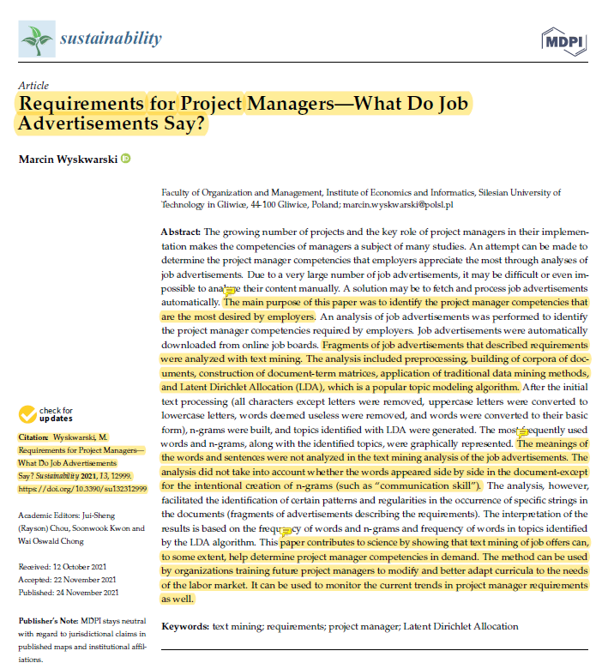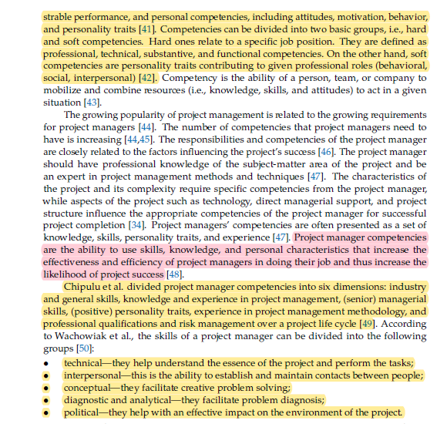 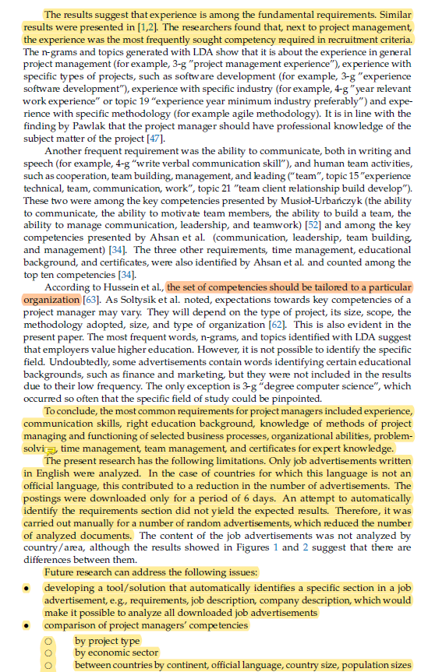

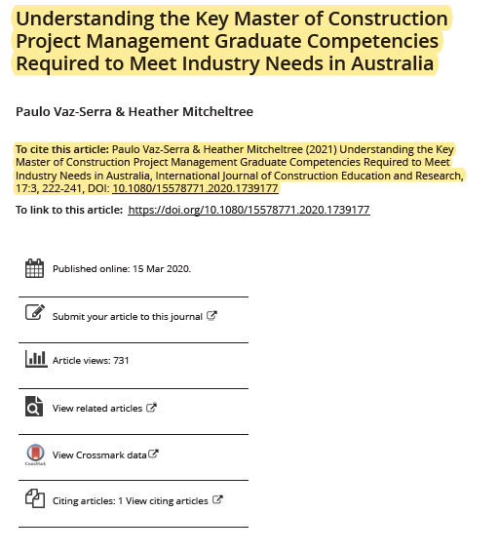 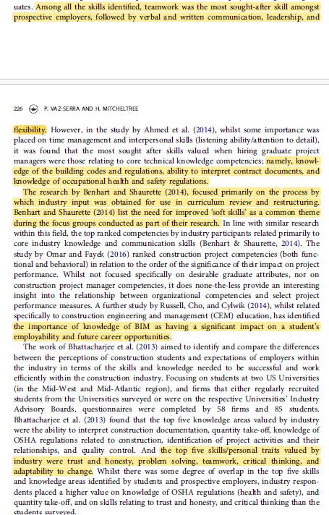 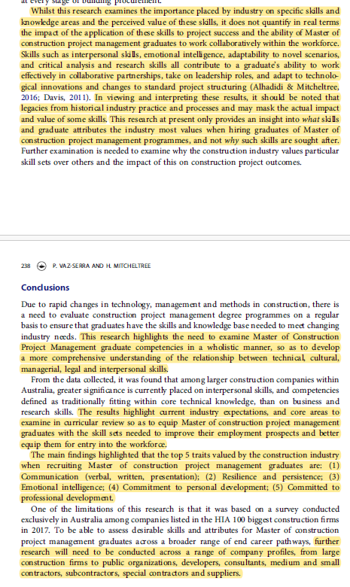

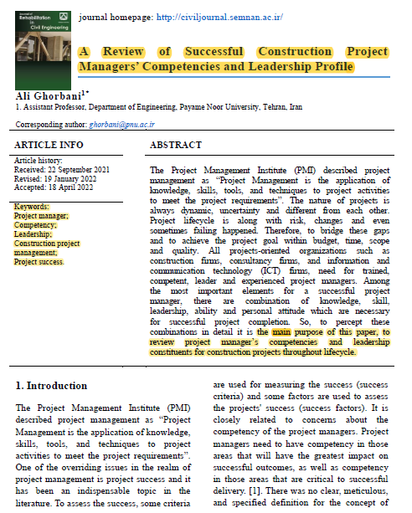 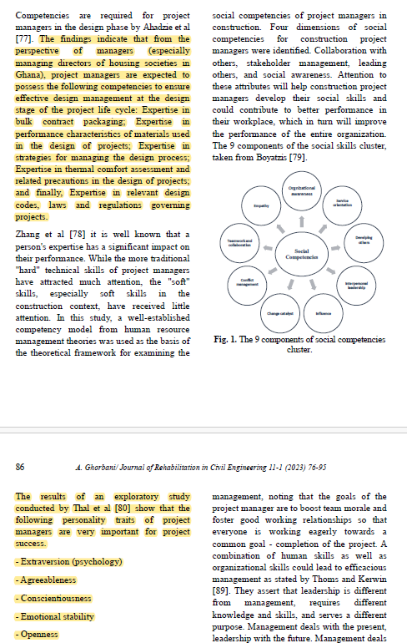 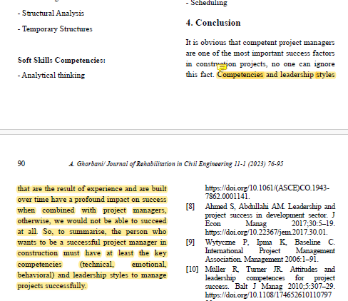

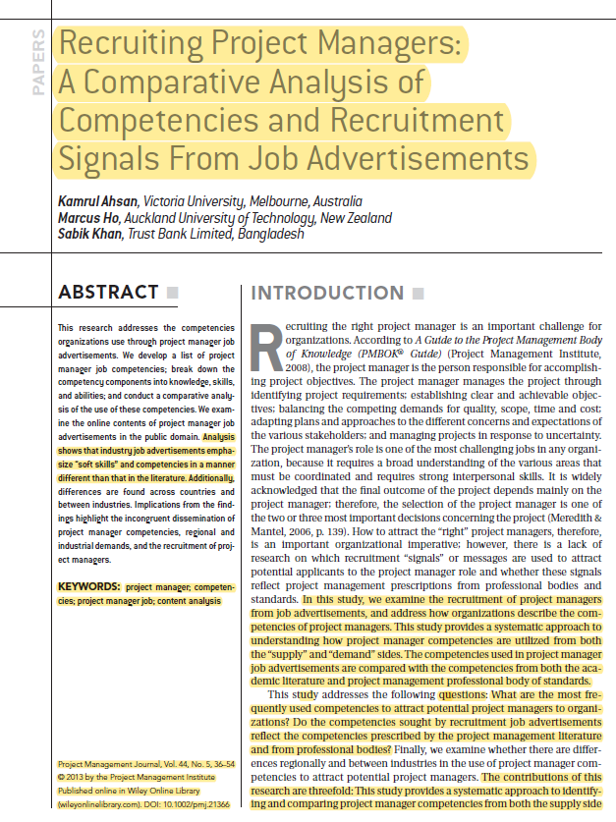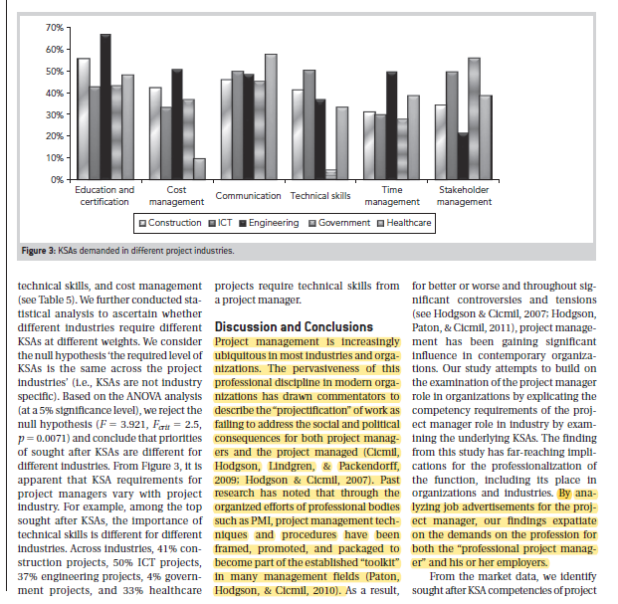 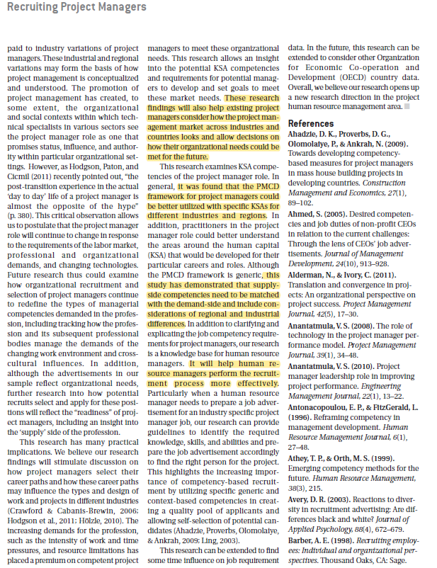

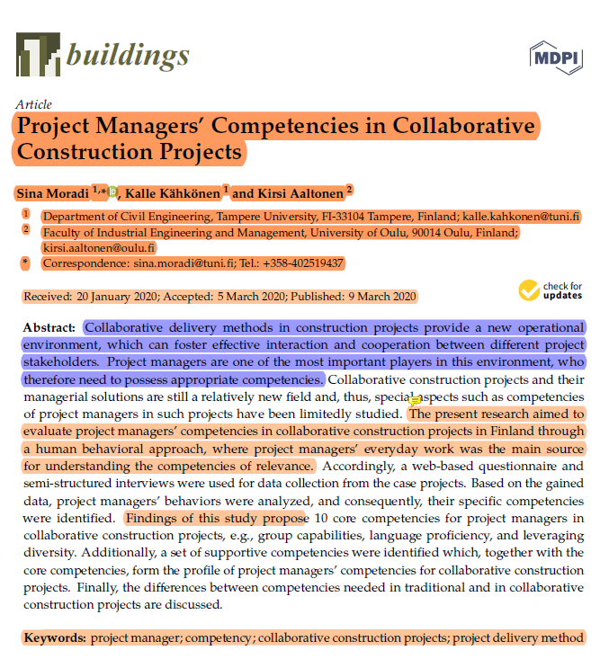 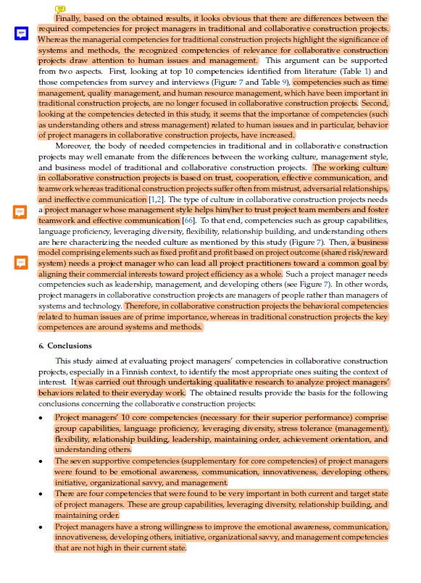 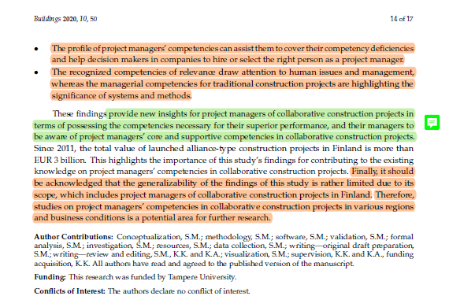

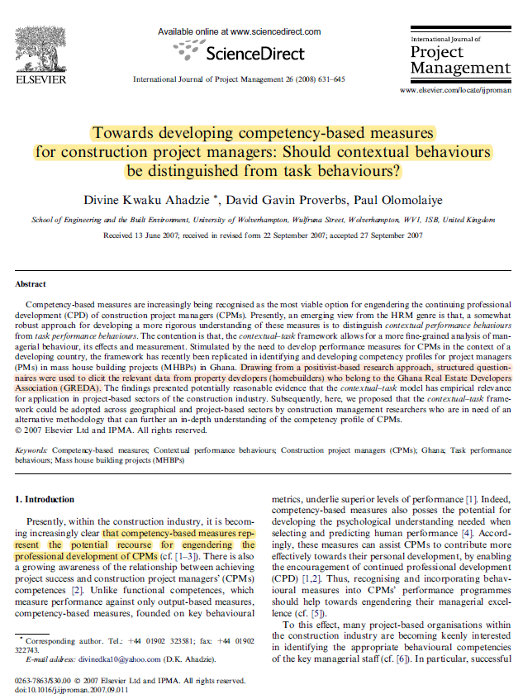 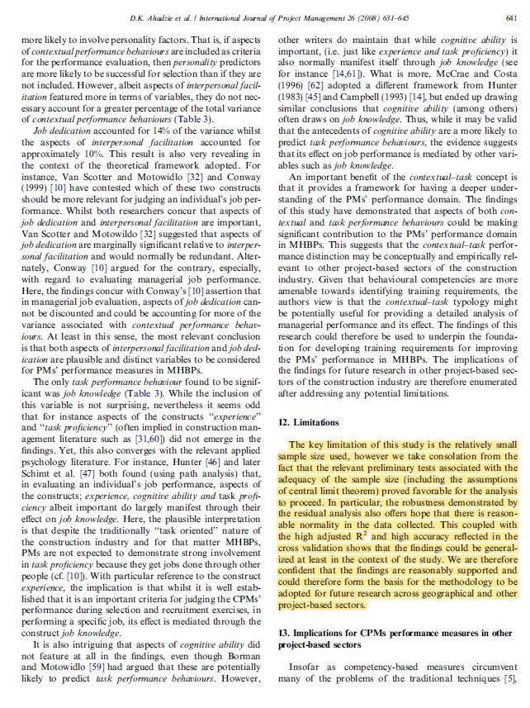 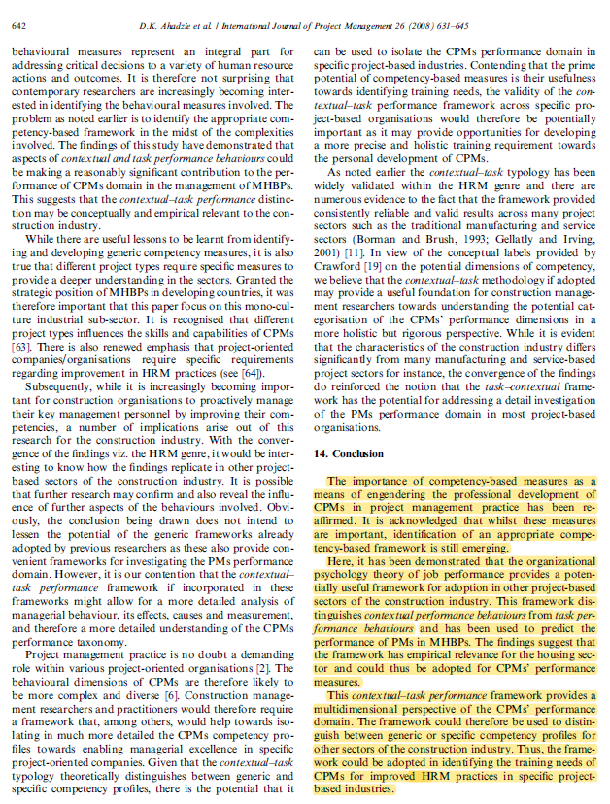

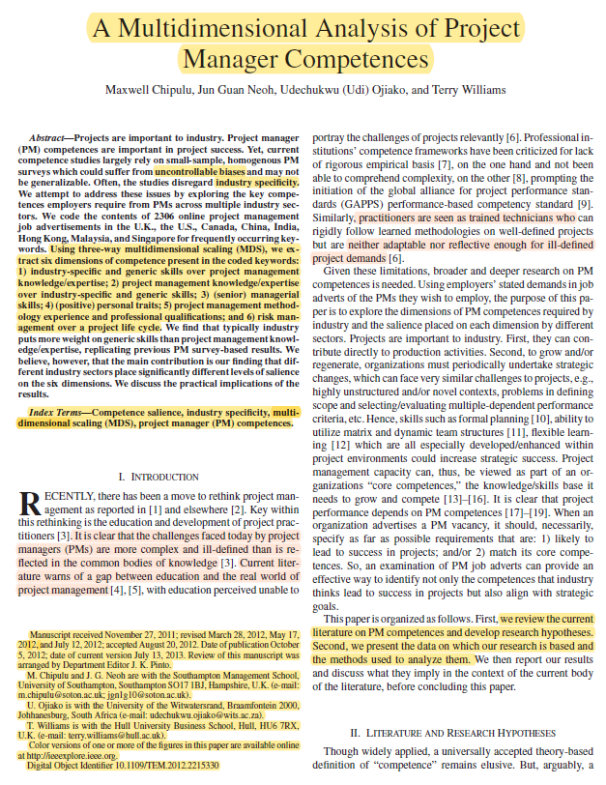 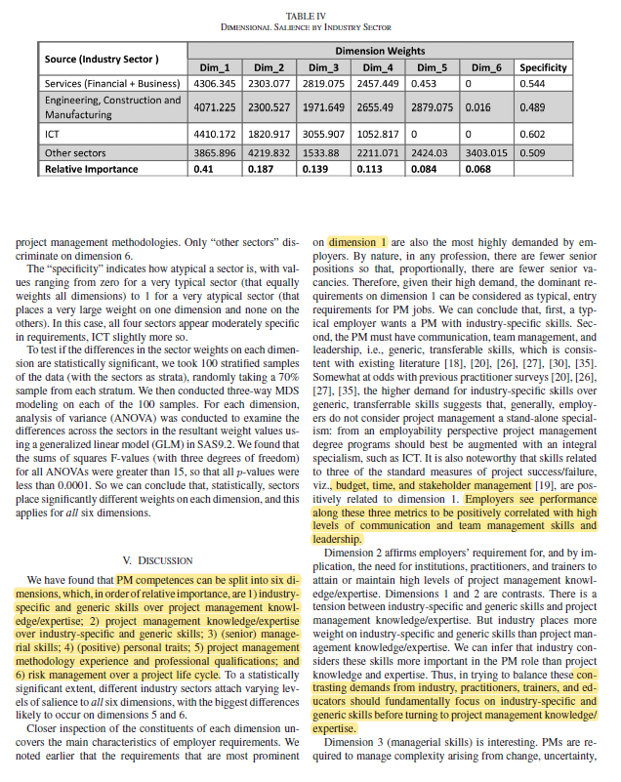 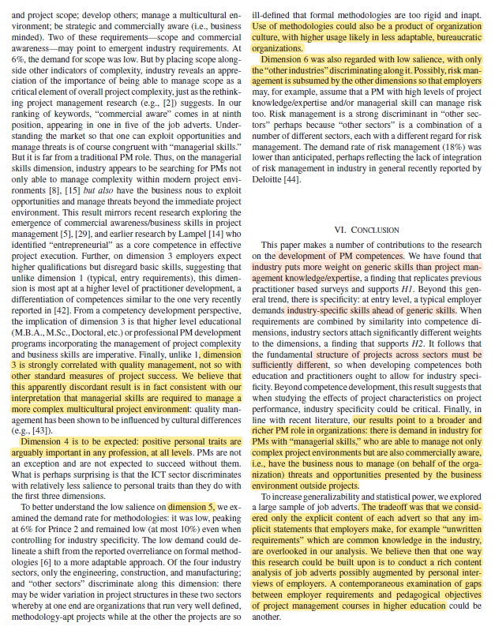

# **Literature Review**

*Requirement for Project Managers- What do Job Advertisements Say?* (Wyskwarski, 2021) This study aimed to discern the competencies most highly sought after by employers when recruiting project managers by leveraging text-mining techniques applied to job advertisements. Job ads served as a valuable source of data for this research, with fragments analysed using a systematic approach that encompassed data preprocessing, document-term matrix construction, traditional data mining methodologies, and Latent Dirichlet Allocation (LDA), a widely used topic modelling algorithm. The analysis focused specifically on the articulation of job requirements in these advertisements, eschewing in-depth semantic analysis of words or sentences, although it did include the creation of intentional n-grams, such as “communication skill”. The significance of this research lies in its demonstration that text mining of job postings can provide valuable insights into the competencies most in demand for project managers. These findings hold potential implications for organizations involved in training future project management professionals, enabling them to tailor their educational programs to better align with the ever-evolving needs of the job market. Additionally, this method can serve as a valuable tool for monitoring and tracking changing trends in project manager requirements over time. Key competencies sought after for project managers encompass a broad spectrum of both hard and soft skills, ranging from technical prowess to interpersonal acumen. These competencies, the study suggests, can vary depending on factors such as the nature of the project, its scale, the adopted methodology, and the specific organizational context. Among the noteworthy findings is the consistent emphasis on experience as a fundamental prerequisite for project managers, corroborating earlier research in this domain. Nevertheless, it is crucial to acknowledge certain limitations, including the focus on English-language job advertisements and the relatively short data collection period. Future research endeavors may explore avenues such as automated section identification tools for job ads, cross-comparisons of competencies across different project types, economic sectors, and country characteristics, as well as the analysis of job advertisements in languages other than English after translation.

*Understanding the key Master of Construction Project Management Graduate Competencies Required to Meet Industry Needs in Australia* (Vaz-Serra & Mitcheltree, 2021)*,* this research conducted further within the construction industry reveals a distinct emphasis on interpersonal skills and competencies typically categorized as core technical knowledge. These aspects take precedence over business acumen, expertise in environmental waste management systems, and sustainability and life cycle analysis. The study examines initial findings derived from a structured survey aimed at discerning essential competencies sought by key personnel in recruitment and senior managerial positions within the Australian construction industry for Master of Construction Management graduates. The survey illuminates the critical skills and competencies currently highly regarded by the industry when considering the recruitment of construction management graduates from master’s level programs. It sheds light on the prevailing industry expectations in Australia concerning the skill sets deemed vital for successful construction project management. Among the myriad skills identified, teamwork stands out as the most coveted attribute for prospective employers. It is closely followed by verbal and written communication skills, leadership qualities, and the process through which industry insights were incorporated into curriculum reviews and restructuring. This study delves deeper into the key competencies large contracting firms value when hiring graduates in Master of Construction Project Management. The research focuses primarily on industry perceptions of the most desired competencies for construction project managers. It should be noted that the survey targeted the top 100 largest construction companies in Australia, potentially leading to differences in skill priorities compared to smaller or medium-sized organizations. Notably, the significance of knowledge in Building Information Modeling (BIM) in shaping career pathways for construction and engineering management graduates is highlighted in the study. However, the survey results did not mirror the same level of importance accorded to BIM knowledge, possibly due to variations in industry focus.

*A Review of Successful Construction Project Managers’ Competencies and Leadership Profile* (Ghorbani, 2023)article discussed that the objective of presenting a new definition in this context isn't to supplant existing ones but rather to offer individual experts a valuable framework conducive to fostering an improvement-oriented mindset. This article's core aim revolves around a comprehensive exploration of key project manager competencies, covering behavioral, managerial, and emotional facets, alongside the delineation of distinct leadership profiles evident in successful projects. These insights are grounded in specific contexts and project types that have undergone meticulous scrutiny and identification. The study's findings underscore that, particularly from the perspective of managers, notably managing directors of housing societies in Ghana, project managers are expected to embody certain competencies critical for ensuring effective design management during the project's design phase. These competencies encompass expertise in bulk contract packaging, a profound understanding of materials' performance characteristics, proficiency in designing process management strategies, adeptness in thermal comfort assessment, and a thorough grasp of pertinent design codes and regulations governing projects. Furthermore, the study reinforces the significance of specific personality traits, such as extraversion, agreeableness, conscientiousness, emotional stability, and openness, in driving project success, highlighting their complementary role alongside competencies in achieving favorable project outcomes. In essence, becoming a successful project manager in construction necessitates the cultivation of key competencies spanning the technical, emotional, and behavioral realms, underpinned by adaptable leadership styles, while acknowledging the profound influence of experience in honing these capabilities over time.

*The framing of construction management responsibilities in job advertisements in the UK and the USA* (Puolitaival et al., 2023)*,* this research delves into the multifaceted realm of construction management responsibilities, examining them from various perspectives, both individual and organizational, within and outside the organization. Responsibilities in construction management encompass a broad spectrum, ranging from the day-to-day tasks of site managers to the contractual obligations of entire organizations. The primary goal of this study is to enrich our comprehension of these responsibilities by scrutinizing how job advertisements portray them for construction management professionals. To achieve this, a documentary research approach coupled with genre and content analyses was employed to qualitatively assess a curated selection of job advertisements from major contractors in the UK and the USA. The genre analysis unveiled a recurring pattern in the structure of these job advertisements, revealing three distinct levels: the role name, an overview of work functions, and a detailed description of responsibilities. Through qualitative content analysis, the study contributes by presenting an evolved definition of construction management alongside a comprehensive typology of responsibilities. The results of this analysis underscore the importance of maintaining alignment between the role name, work function overview, and responsibility description within job advertisements. This coherence is vital in attracting suitable candidates effectively. Furthermore, this research highlights the interplay between the second and third levels, showcasing a spectrum of detail in which responsibilities are articulated. Some job advertisements provided intricate descriptions at the second level, akin to the third level in other ads, while others offered vague outlines. The examined sample generally adheres to this framework, excluding only a few instances. Ultimately, this study distills 31 distinct responsibility areas, providing a concise overview of construction management responsibilities and a comprehensive understanding of the field. The findings can serve as a framework for categorizing results from studies on individual professionals' roles and responsibilities within the construction management domain. In essence, this research contributes valuable insights into the intricacies of construction management responsibilities, shedding light on how they are presented and articulated in job advertisements and emphasizing the importance of coherence in attracting suitable candidates.

*Recruiting Project Managers: A Comparative Analysis of Competencies and Recruitment Signal from Job Advertisements* (Ahsan et al., 2013)*,* this research delves into the realm of project manager competencies as reflected in job advertisements, shedding light on the skills and attributes sought by organizations. The study involves the development of a comprehensive list of project manager job competencies, further dissecting these competencies into distinct categories of knowledge, skills, and abilities. Through a comparative analysis of these competencies, the study aims to uncover patterns in their utilization. To achieve these objectives, the research scrutinizes the contents of project manager job advertisements available in the public domain, particularly focusing on the online medium. The analysis reveals that job advertisements within various industries place particular emphasis on "soft skills" and competencies, a departure from the patterns observed in the existing literature. Moreover, disparities emerge when comparing the emphasis on competencies across different countries and industries. These discoveries have important repercussions that should be considered. They highlight the disparity in the application of project manager competencies, which reflects differences in requirements and hiring procedures between regions and industries. Understanding these skill dynamics is essential in a time when project management has proliferated across numerous industries and organizations. Notably, this study adds to the conversation about the effects of "precertification" on project managers and the projects they oversee. It emphasizes the crucial role professional organizations, such the Project Management Institute (PMI), have had in presenting and marketing project management concepts and processes as vital management tools. This study offers useful insights into the changing demands placed on experts in this industry by examining project manager job advertisements.

Furthermore, both experienced and aspiring project managers can benefit from this research's conclusions. They offer a glimpse into the diverse project management landscape across industries and countries, aiding individuals in making informed decisions about their career paths. Ultimately, this study underscores the importance of aligning supply-side competencies with the demand-side requirements while considering regional and industrial disparities, offering guidance to human resource managers for more effective recruitment processes.

*Developing project Management competency: perspectives from the construction industry* (Edum-Fotwe & McCaffer, 2000)*,* this paper presents a study that delves into the development of construction project managers and the strategies they employ to maintain their professional skills within the evolving landscape of the construction industry. While this research is highly pertinent to the cultivation of future project managers, it does not comprehensively address the myriad challenges that project managers currently face in today's dynamic industry environment. The study unfolds the findings of a survey designed to scrutinize how construction project managers acquire and refine the essential skills and knowledge required for effective practice in their roles. The results gleaned from this study serve to pinpoint valuable lessons and offer viable options that can serve as valuable insights for designing in-house training programs for construction organizations' incumbent project managers. Moreover, the insights garnered from this research can also inform the development of academic and industry-based programs tailored to train the next generation of project managers. The study notably underscores the significance of certain generic knowledge areas that construction project managers are typically expected to amass, as outlined by various Accreditation Bodies. These knowledge domains mirror the technical prerequisites for certification within the field. However, contemporary project management practices extend beyond mere technical proficiency, necessitating a broader spectrum of general management knowledge and a diverse set of skills. To execute this research, a combination of research instruments was employed, including the interview technique and a postal survey option. The interview method was administered to a select group of organizations, wherein several in-depth interviews were conducted with key professionals. These interviews were instrumental in assessing the criteria for the successful selection of project managers and in identifying the metrics for various factors outlined in the research objectives. Nonetheless, it is important to acknowledge that this research, while valuable, may not fully capture the holistic perspective required for senior project management roles. It might not encompass the broader outlook demanded by the senior position of a project manager, which necessitates a multifaceted skill set and a comprehensive understanding of the complex and dynamic construction industry landscape.

*Project Managers’ Competencies Model for the Construction Industry in Poland* (Dziekoński, 2017)*,* this study aims to develop a competency model for construction project managers in Poland. The created model is intended to serve as a reference for adopting an integrated approach to managing construction projects in Poland. The researchers distributed a questionnaire online over the course of a year, from January to December 2015. Respondents were asked to assess their level of competency as project managers and their general competency in managing construction projects using a Likert scale. Since not all respondents were project managers, the study examined the differences in responses between engineers acting as project managers and team members. The Mann-Whitney test was employed for this purpose. The data analysis method chosen for the study was clustering, which groups together objects that share more similarities with objects in the same cluster than those in other clusters. The clusters identified through data analysis shed light on the complexity of competency in construction project management. Some clusters highlighted competencies that are supportive in team management and people management. However, only the features within cluster 3 (cognitive approach) and cluster 4 (generic approach) seemed to align with specific definitions of competency, such as the behaviorist, generic, and cognitive definitions. The study did not determine which competencies within these clusters have the most significant impact on the competence of construction project managers. The results of this research can be valuable for human resources (HR) departments in construction companies when designing professional development programs for project managers. Additionally, individual engineers responsible for construction projects can use these findings to guide their personal development.

*Comparison of research and Industry views on project managers’ competencies* (Moradi et al., 2020a)*,* the purpose of the paper is to examine potential differences between research findings and established standards regarding the competencies of project managers. This is achieved through a comprehensive literature review that encompasses previous research studies and relevant standards of practice. The analysis involves identifying competencies mentioned in these studies and standards, ranking them based on their frequency of appearance, and drawing conclusions from the findings. The paper identifies four main discrepancies between research results and standards of practice:

1. Commonly Existing/Missing Competencies: Some competencies may be consistently highlighted in research studies but are missing or not emphasized in established standards. Conversely, competencies that are emphasized in standards may be less frequently mentioned in research.

2. Uneven Priority of Competencies: There may be variations in the perceived importance of certain competencies between researchers and established standards. Some competencies may be prioritized differently, potentially reflecting differing viewpoints on their significance.

3. Consensus on Competency Importance: The degree of consensus on the importance of specific competencies may vary. Some competencies may have broad agreement among researchers, while standards of practice may have a different perspective.

4. Contextual Emphasis: Research findings might be more situation-specific, taking into account the unique conditions under which project managers work. In contrast, standards of practice may have a more generalized approach. The paper suggests that project managers need competencies that align with the contextual demands of their projects for successful outcomes.

The paper adopts a definition of competency as the ability to use skills, knowledge, and personal characteristics to enhance project managers' efficiency and effectiveness, ultimately increasing the likelihood of project success. Furthermore, the research delves into context-specific competencies for project managers, considering the principles of contingency theory. This analysis highlights the need for senior managers and human resources departments in project-oriented companies to understand the key competencies required for superior performance. By focusing on these key competencies, decision-makers can make more informed choices when selecting project managers. As a limitation, the paper acknowledges that critical discussions and alternative viewpoints regarding project managers' competency research have not been extensively explored, suggesting that further research in these areas could be beneficial.

*A Multidimensional Analysis of Project Manager's Competences* (Chipulu et al., 2012)*,* the paper focuses on a comprehensive examination of competencies essential for project managers (PMs) by utilizing a three-way multidimensional scaling (MDS) approach, resulting in the identification of six distinct competence dimensions. These dimensions, ranked by relative importance, encompass 1) the precedence of industry-specific and generic skills over project management knowledge/expertise; 2) the hierarchy of project management knowledge/expertise over industry-specific and generic skills; 3) the significance of (senior) managerial skills; 4) the role of (positive) personal traits; 5) the relevance of project management methodology experience and professional qualifications; and 6) the impact of risk management across a project's life cycle. The study underscores the evolving and intricate nature of contemporary project management, highlighting the need for adaptability among PMs. Data was collected from job advertisements, and the research combines qualitative and quantitative methods to analyse competence dimensions. Employers value PMs who exhibit strong communication, team management, and leadership skills across these dimensions, with particular emphasis on industry-specific expertise and managerial acumen. The findings suggest that prioritizing industry-specific skills over project management knowledge is essential, and there is an increasing demand for PMs with business acumen.

*Project Managers’ Competencies: What Do Job Advertisements and the Academic Literature Say,* this article (do Vale et al., 2018) employs a comprehensive research approach that combines a systematic literature review (SLR) with an analysis of job advertisements to investigate the fundamental competencies of project managers. The study’s primary objective is to identify the key competencies required for project managers, considering both academic and labor market perspectives. The research process comprises various phases, including the sampling phase, bibliometric immersion, and content analysis facilitated by tools like Sitkis, Ucinet, and Netdraw. The subsequent cross-analysis aims to extract valuable theoretical insights and outline potential avenues for future research. Notably, the findings reveal a discrepancy: while the academic literature places significant emphasis on technical and contextual competencies, job advertisements prioritize managerial skills. This study, however, has certain limitations, including the exclusive use of the ISI Web of Science database for the literature review and a focus on job advertisements from just five Brazilian websites.

*Towards Developing Competency-based Measures for construction project managers: Should contextual behaviours be distinguished from task behaviour?,* Utilizing a positivist-based research approach, this study (Ahadzie et al., 2008) employed structured questionnaires to gather pertinent data from property developers, specifically homebuilders who are members of the Ghana Real Estate Developers Association (GREDA). The research underscores the significance of competency-based measures in fostering the professional development of Construction Project Managers (CPMs). These measures encompass a range of competencies such as expertise in site layout techniques for repetitive construction, commitment to aiding contractors in adhering to project schedules, knowledge of technology transfer for repetitive construction, efficient time management in housing projects, conflict resolution capabilities while maintaining positive relationships, and the ability to assist contractors with personal issues. The primary limitation of this study pertains to the relatively small sample size; however, preliminary tests validating the sample size and the robustness demonstrated in the data analysis suggest that the findings can be reasonably generalized within the study's context. The study reaffirms the importance of competency-based approaches for enhancing the professional growth of CPMs in project management practice. While these measures are acknowledged as crucial, the identification of a suitable competency-based framework is an ongoing process. The study introduces the organizational psychology theory of job performance as a potentially valuable framework for application in other project-based sectors within the construction industry. This framework distinguishes between contextual and task performance behaviors and has previously been used to predict the performance of PMs in Major House Building Projects (MHBPs). The findings indicate that this framework has empirical relevance in the housing sector and could be adopted for assessing the performance of CPMs. This multidimensional framework offers insights into CPMs' performance by considering both contextual and task-related aspects, making it adaptable for identifying competency profiles in various construction industry sectors.

*Competence Model of Construction Project Manager in the Digital Era- The Case From China,* In response to the evolving digital landscape of the construction industry, there is a pressing need for a new competency model tailored to Construction Project Managers (CPMs) to address emerging requirements. This study employs a data mining approach, harnessing 2387 pieces of big data from recruitment advertisements within the Chinese construction market spanning from August 2020 to October 2021. This extensive dataset serves as the foundation for constructing the "Diamond" model of CPM competence in the digital era. The model introduces a hierarchy pyramid structure for assessing mastery levels of digital capabilities, categorizing them into three tiers: technology level, knowledge level, and management level. Historically, understanding the competencies requisite for CPMs has been a pivotal research question within the construction industry. The traditional method for exploring the demand for specific occupational competencies involves literature reviews. However, data mining offers distinct advantages. Firstly, it effectively mitigates the limitations of small sample sizes by collecting a vast number of job advertisements. Secondly, data collection occurs over a specific time, providing an objective reflection of dynamic shifts in the construction industry's demands for project manager skills during that interval. Thirdly, by relying on extensive datasets and minimizing human intervention, data mining mitigates retrospective bias concerns often associated with expert interviews. Through this methodological approach, the study defines a comprehensive framework for CPM competencies in the digital age, encompassing nine core competencies: Organizational Management Capability, Integrated Project Management Capability, Professional and Technical Capability, Construction Site Management Capability, Experience and Certification, Coordination and Communication Capability, External Stakeholder Management Capability, Digital Capability, and Project Team Management Capability. The Diamond model comprises two components: the first being external, featuring eight-dimensional capabilities, while the central component is the one-dimensional digital capability. However, several avenues for future research and improvement are evident. Firstly, given the dynamic nature of CPM competency demands in the digital era, an analysis spanning a longer timeframe is warranted to capture long-term industry trends. Secondly, the current high-level competencies require further granularity, translating them into specific indicators that can be operationalized with questionnaire data. Lastly, as the study's findings are grounded in the context of the Chinese construction industry, broader validation across different countries and industries is essential to enhance generalizability beyond this specific context.

*Project managers’ Competencies in Collaborative Construction Projects* (Moradi et al., 2020b), Collaborative delivery methods have introduced a transformative operational environment in construction projects, emphasizing effective interaction and cooperation among diverse stakeholders. Within this context, project managers play a pivotal role and require specific competencies to thrive. This research delves into the evaluation of project managers' competencies in collaborative construction projects within Finland, employing a human behavioral approach rooted in their day-to-day work experiences. The primary objective is to identify the competencies pertinent to project managers in this collaborative setting. The study employs two distinct data collection methods: a web-based questionnaire and semi-structured interviews. The questionnaire assesses project managers' competencies by analysing the frequency and nature of behaviours exhibited in their daily work, while semi-structured interviews validate the findings. The outcomes underscore notable distinctions in the required competencies for project managers in traditional versus collaborative construction projects. Traditional projects emphasize managerial competencies centred around systems and methods, whereas collaborative projects highlight human-centric issues and management skills. Notably, competencies related to human factors and project manager behaviour, such as understanding others and stress management, gain prominence in collaborative construction projects, while traditional project competencies like time management, quality management, and human resource management become less focal. The working culture in collaborative construction projects thrives on trust, effective communication, teamwork, and cooperation, in stark contrast to traditional projects, often marred by mistrust, adversarial relationships, and poor communication. Project managers in the collaborative setting exhibit management styles that promote trust, teamwork, and effective communication. A business model incorporating elements like fixed profit and shared risk/reward systems requires project managers capable of aligning commercial interests toward overall project efficiency. In collaborative construction projects, competencies related to human issues take precedence, while traditional projects emphasize systems and methods. The research unveils ten core competencies for project managers essential for superior performance, including group capabilities, language proficiency, leveraging diversity, stress tolerance management, flexibility, relationship building, leadership, maintaining order, achievement orientation, and understanding others. Additionally, seven supportive competencies supplement the core ones, encompassing emotional awareness, communication, innovativeness, developing others, initiative, organizational savvy, and management. Four competencies are deemed highly important in both current and target states for project managers: group capabilities, leveraging diversity, relationship building, and maintaining order. The study identifies competency gaps, particularly in emotional awareness, communication, innovativeness, developing others, initiative, organizational savvy, and management, highlighting areas where project managers are keen to improve. The competency profile derived from this research equips project managers to address their competency deficiencies and aids decision-makers in selecting the right individuals for project management roles. It underscores the pivotal role of human-centric competencies in collaborative construction projects, as opposed to the traditional focus on systems and methods. While offering valuable insights, it's important to note that the study's findings have limited generalizability due to their context within collaborative construction projects in Finland. Future research should explore project managers' competencies in collaborative construction projects across various regions and business conditions to enhance the breadth of understanding in this area.

*Competencies Required by Project Managers for Housing Construction in Ghana,* The purpose of this paper is to explore the perspectives of senior managers regarding the competencies required by project managers (PMs) in Ghana (Ahadzie et al., 2009), specifically for mass house building projects (MHBPs). The study aims to discuss the implications of these findings for professional training and development in the field. Drawing upon well-established organizational psychology theory related to job performance, the research utilized a structured questionnaire survey to collect data from managing directors (MDs) representing homebuilders associated with the Ghana Real Estate Developers Association (GREDA). The collected data underwent analysis using multiple regression techniques, specifically a stepwise approach. Competency-based measures have gained increasing importance in identifying and developing practical training requirements. These measures form a continuous and cyclical process that involves assessment, planning, and corrective action. The research conceptualized a model to guide its focus, encompassing performance behaviours and outcomes at various project lifecycle phases, including concept, design, tender, procurement, construction, and operational stages. The research findings highlight several key competencies that significantly predict PMs' performance during the construction phase of MHBPs. These competencies include job knowledge in site layout techniques for repetitive construction work, dedication in assisting works contractors in meeting project schedules, understanding appropriate technology transfer for repetitive construction processes, effective time management for house units, conflict resolution abilities while maintaining positive relationships, approachability for works contractors, and a willingness to aid in resolving personal issues. Notably, these competencies are instrumental in ensuring successful project management in the context of mass house-building projects. Furthermore, the study discerns that task-oriented competencies, such as site layout knowledge and technology transfer expertise, account for 52 percent of the managerial performance domain. Meanwhile, contextual competencies, encompassing dedication, time management, conflict resolution with relationship maintenance, approachability, and voluntary assistance to contractors, explain 24 percent of the performance variance. These competencies align with theoretical expectations and hold promise for practical application by industry practitioners.

*A competency-based performance model for construction project managers* (Dainty et al., 2004)*,* this paper delves into the development and validation of a competency model aimed at predicting employee performance. Statistical techniques were employed to create this model, which was subsequently validated using a separate criterion sample. The study explores the potential applications of this framework in the pursuit of performance excellence within the industry. It can be used in various Human Resource Management (HRM) functions such as selection, management development, succession planning, performance management, and team deployment. The research process involved several key steps: (i) Identifying the criteria defining effective performance, (ii) Forming criterion sample groups of superior performers and average employees for comparison, (iii) Collecting data through behavioural event interviews, (iv) Identifying competencies that distinguish superior from average performers, (v) Validating the competency model, and (vi) Applying the model across various HRM functions. Utilizing statistical techniques, data from the criterion sample groups were leveraged to construct a model that describes competencies predicting superior job performance. The study used a one-way analysis of variance (ANOVA) to identify competencies distinguishing superior managers from those performing at an average level. Logistic regression analysis (forward stepwise) was then employed to determine the most predictive competencies among the 12 identified, ultimately generating a concise model for predicting job performance. The paper underscores the importance of linking competencies to appraisal and reward in the context of performance management. Failing to establish this connection can limit the value of competencies in facilitating organizational growth and development. The competency model is presented as a framework, necessitating further development to align with the values, culture, and business environment of the organization where it is applied.

# **Research Methodology**

The dynamic nature of this industry necessitates a thorough comprehension of the constantly changing skills and competencies needed by project managers in the construction industry. Since this study aims to analyse the skills and competencies of project managers in the construction industry through online job advertisements, Content analysis method is more appropriate which comprises of integrated approaches such as qualitative and quantitative methods. Content analysis is the research technique that enables the inferences to be made based on the text considering the context in which it is written. Qualitative analysis method provides the conceptual framework, whereas Quantitative analysis provides measurable terms for the framework. Qualitative content analysis demands meticulously reading each document, understanding and interpreting the text in its relevant context and finally it is followed by coding and classifying each of the text units. In contrast, Quantitative analysis summarises the inferences and the insights derived from the qualitative phase in the form of numerical of the interpreted text units and related sub groups. Based on the above definitions, our topic demands to adopt both qualitative and quantitative content analysis methods accordingly.

The study requires a systematic approach in identifying and comparing project manager competencies from both the supply side and demand side, it provides a framework for understanding the recruitment of project managers, including the signals that organizations communicate to potential candidates through job advertisements; and, last, it should also look into the utilization of project manager competencies from theoretical, regional, and industry perspectives (Ahsan, K., Ho, M., & Khan, S. 2013). Job advertisements from various countries and comparing how the construction management responsibilities and also identifying the differences in presenting the roles and responsibilities (Taija Puolitaival, Kalle Kähkönen & Linda Kestle 2023).

With reference to our selected topic, Content Analysis to review project management job advertisements to identify the different perspectives of the roles and responsibilities. The perspectives such as task system, stakeholders, leadership, business by projects and transaction cost are considered and analyzed in line with the job advertisements. Completion of the project depends on the budget and on time delivery depends on the required contractual conditions. Control methods and planning of the project plays an important role with reference to the perspectives (Ahsan, K., Ho, M., & Khan, S. 2013). Leadership, Communication, Uncertainty and learning depends on leadership perspectives. On the contrary, system perspectives depend on the problem-solving technique which is to be considered the total picture rather than individual components. Issues with the stakeholder perspectives are communication, negotiation, relationships, influences and dependents. Contract development, negotiation, execution incentives, innovation process were used in stakeholder perspective. At last, the business perspective deals with project investment, strategy, results and benefits. This study tries to bring the understanding of the concepts by the construction project manager and the requirements of the potential employer.

The primary rationale for identifying the project manager skills and competencies to accommodate the industry needs in the changing environment by analysing and comparing about 200 job advertisements posted on Seek i.e., Job Advertisement agency/company depending on various selection criteria such as experience, qualification, value of the project, type of the project, duties/responsibilities ,proficiency skills in software related to the construction industry, work rights in Australia / New Zealand with respect to India i.e. .,Naukri.com ( widely used job portal).The analysis will be performed based on content analysis which includes both qualitative and quantitative techniques in an integrated manner.

Firstly, project manager job related key categories are identified based on the previous literature review, identifying job advertisement websites such as Seek and Naukri, collecting various sample data from the website, job advertisement contents and their frequencies are searched and collected respectively, and job advertisements frame the duties and responsibilities of construction management professionals. According to the job advertisements, construction management professional to look for the duties and responsibilities across the roles but should not be limited to specific role (Puolitaival et al., 2023)*.*

Project manager job related key categories are identified based on the previous literature review

To begin our research first step is to create variable labels which will form the basis of our data collection. To form that the previous literature review is closely analysed and variable labels such as leadership, effective communication, planning skills, project technical expertise, decision making skills, interpersonal skills, soft skills, and team building and management etc., most frequently asked are identified and grouped together to collect the data. The frequency of the variable labels is closely checked and noted down for the analysis. The variable labels which are a greater number of times appeared in the literature review are given highest weightage and least weightage is given in opposite of the contrast. The primary objective of the study is not to avoid the any specific literature which contains variable labels that might result in potential sampling error.

Identifying job advertisement websites such as Seek and Naukri

Identification of job advertisements are captured either in the form of print or online platforms. There are many numbers of print medias available such as newspapers, magazines and journals. But the published advertisements are tended to be very short and less precise as space availability is allocated based on the charges by the agency. Henceforth, we decided to choose only online platforms which contains the maximum details which will be useful for our research output. Furthermore, these online sources are easier to access, navigate and also in finding the intended advertisements in a manageable way. Job advertisements from various online platforms are collected, categorized and analysed based on the country, industry, position, roles and responsibilities. As per our chosen topic the preliminary keyword being used “construction project manager” in 200 job advertisement websites which are published in SEEK and Naukri.

The major construction companies always chose to advertise their requirements in SEEK as it is widely used by the many in Australia which is contrast to the Naukri.com which is extensively used in India. These two are more popular among the job seekers as well as job advertisers in their region respectively. The rich cross-section of jobs is published where it is to potential, comprehensive and dedicated source of job advertisements accordingly. In Australia, SEEK hosts close to more than 60% of all their jobs on Australia’s major job sites. But in India Naukri.com dominates the online portals by capturing the market with close to 80% in comparison to their competitor.

We use these job websites to avoid and omit duplications as number of advertisements published repeatedly. The contents published are more reliable and trustable as the major details are collected in the precise manner without wasting time (Ahsan, K., Ho, M., & Khan, S. 2013).

Collecting various sample data from the website

Before starting data collection, the variable labels which we are using are to be ensured to cover most sought-after construction project manager skills and competencies related key words. Our main aim is to start by analysing 200 job advertisements in the preliminary phase. The key variable labels are merged and grouped based on literature review, content analysis from the job advertisements. Different industries from Australia and India are covered under these published advertisements. The variable labels identified (described earlier) from the literature has to be checked and find out if further changes are required. Further more this will help in identifying new set of variable labels which is useful in the analysis of the collected data. This may include safety, quality and compliance requirements. Merging of few variable labels over the initial ones are considered as they have similar meanings in order to attain accuracy. Before the commencement of actual data collection, all the necessary data will be in chronological order so that to enable smooth flow.

Job advertisement contents and their frequencies

The job advertisements are to be collected between the month of December and February as most of the companies recruit construction project managers in the beginning of the year as most of the projects are awarded during this time frame. These relevant advertisements are to be thoroughly scanned and key variable labels are to identified and grouped according to their weightages. The process of printing has to be carried out for each job advertisement and marking is to be done with the reference number and filing under respective country and industry. The entire process takes place manually without the use of content analysis software where the accuracy obtained is superior in data collection, and falls in line with the context with the human involvement. Job advertisement is our unit of analysis.

Identified variable labels from the job advertisements are considered for tabulation as per the data base. In addition, with the skills and competencies we also record some other data which are relevant to the industry such as job title “construction project manager”, company or agency, salary benefits such as superannuation, vehicle, parking facility, food allowances, laptops, mobile and uplift allowance for FIFO, DIDO type of jobs and size of the project.

To ensure the accuracy, the coded data is then to be crosschecked to find out the identical results without any error. This is to be validated by both the researchers by randomly checking the website with the same variable labels and the results to be recorded inorder to identify the discrepancies if any. This process has to be carried out to ensure with negligible errors, which has to be resolved upon further discussion.

**RESEARCH METHOD**:

Literature Review

Content Analysis

Qualitative Analysis

Conceptual Framework

Reading each document

Quantitative Analysis

Understanding & interpreting the text

Converts into numerical form

Coding and Classifying

Insights and Inferences

# **Project Management Implementation Plan**

**Risk Management:**

The following top five risks are to be identified in early stages of the research

1. Incomplete information: Advertisements for job positions may lack exhaustive details regarding the necessary skills and competencies, resulting in potential voids or shortcomings in your analysis
2. Regional variation: The skills and competencies desired in construction project management may exhibit considerable regional or national variations, posing difficulties in forming generalized conclusions
3. Limited accessibility: A portion of job postings might not be accessible to the public, which can restrict the breadth of your analysis and potentially introduce a bias in the selection of data
4. Changing Industry trends: The construction sector is constantly changing, and the skills and competencies in demand can swiftly evolve. Your discoveries may become outdated in a short span of time
5. Language and terminology: Job postings may employ diverse terminology or wording when describing skills and competencies, creating challenges in standardizing the analysis

**RISK REGISTER INCLUDING ANALYSIS AND RESPONSE STRATEGY**

|  |  |  |  |  |  |
| --- | --- | --- | --- | --- | --- |
| **No.** | **Risk** | **Probability**  **(1 very low,**  **5 very high)** | **Impact**  **(1very low, 5 very high)** | **Assessment**  **(impact x probability)** | **Response strategy** |
| 1 | Incomplete Information from the employer or the recruitment agency | 2 | 5 | 10 | Risk mitigation |
| 2 | Regional variation according to the nature and origin of the country | 2 | 5 | 10 | Risk mitigation |
| 3 | Limited Accessibility as the job advertisements is not openly available in all websites | 2 | 4 | 8 | Risk mitigation |
| 4 | Changing industry trends as the construction industry is dynamic in nature | 2 | 3 | 6 | Risk mitigation |
| 5 | Language and Terminology are different to advertises skills and competencies | 3 | 5 | 15 | Risk mitigation |

**Budget and Resources**

|  |  |  |
| --- | --- | --- |
| Research Resources | Description | Annual fees/USD |
| Online Job Portals and Databases | Access to online job portals and construction industry databases is essential to collect a diverse set of current job advertisements. | 1000 |
| Academic Resources | Access to academic journals, scholarly databases, and relevant research papers supports the literature review, providing a concrete theoretical foundation for the study. | 500 |
| Miscellaneous expenses and contingency fund | Cost to include office supplies, communication costs and allocate a portion od the budget for unforeseen expenses or changes in the research plan | 300 |

**DATA MANAGEMENT**

The effective data management is essential for our research. Data will be collected from online job advertisements posts and will be clearly documented and stored. All the data collected will be entered manually in case of non-availability of structured data. Cross-checking of data is essential for accuracy and completeness. During the process, the duplication of job postings will be identified and removed. The formal steps have to be incorporated in order to manage errors and inconsistencies. All the collected data will be secured and stored in the cloud system with providing accessibility to other members depending on data volume and requirements of security. The working data will be shared using Microsoft SharePoint to simultaneously work on the research topic. The weekly backup is done on regular basis by one of the members of the team with external hard disk in order to avoid the technical / hardware failures. Further to protect privacy personal and sensitive information such as names and contact details will be removed. Research findings comprising summary reports and academic publications will share with members of academic institutions for the evaluation and grading. The collected data for the research projected shall be maintained for the specified particular period of time till the dispose shall be discussed and agreed with the project supervisor and Incharge. Data shall be archived and securely stored and labelled for future references.

Several interrelated issues, including technical improvements, shifting market dynamics, and changing stakeholder expectations, are causing significant changes in the field of construction project management. It is critical to provide construction project managers with the knowledge and abilities necessary to succeed in this fast-paced environment considering these changes. This project management implementation plan describes a thorough approach to dealing with fundamental project management issues, making sure that construction project managers have the flexibility and competence required to succeed in the construction sector.

Objective: This project management implementation plan's main goal is to close the gap between existing theoretical knowledge and current industry standards for project management in the construction sector. The plan will concentrate on crucial areas that are crucial for success in the field to accomplish this. These fundamental areas of project management include:

1. Technical Proficiency

*Training Programs:* Create and implement specific training programs that give project managers in the construction industry the most recent technical know-how. This includes being knowledgeable about BIM and other digital tools as well as construction technology.

*Certifications:* To demonstrate their technical proficiency, construction project managers should be encouraged and assisted in acquiring applicable certifications, such as Project Management Professional (PMP) and LEED (Leadership in Energy and Environmental Design).

1. Soft Skills and Adaptability

*Communication Skills:* Stress the significance of having strong communication abilities because construction project managers must communicate with a variety of teams, stakeholders, and regulatory bodies.

*Aptitude:* Develop adaptability and problem-solving skills by including situations and exercises in training programs that mimic real-world difficulties.

1. Sustainability and Regulatory Compliance

Sustainability Training: Include sustainability concepts in the curriculum to help construction project managers understand sustainable construction methods and stay on top of changing environmental requirements.

Regulatory Updates: Set up systems for ongoing learning and keeping up of evolving rules and compliance requirements.

1. Project Management Fundamentals

Advanced Project Management Training: Strengthen conventional project management instruction by including cutting-edge ideas designed for the dynamic character of the construction sector.

Risk Management: To deal with the uncertainties present in building projects, place a focus on risk assessment and management techniques.

1. Geographical Considerations:

Area Focus: Tailor training and educational curricula to consider area differences, such as specific building codes, climatic circumstances, and cultural considerations.

Global Perspective: To equip construction project managers for worldwide projects and promote a global perspective.

Steps for Implementation, the following actions will be conducted to achieve the goals stated in this project management implementation plan:

1. Curriculum Enhancement:

* Work with academic institutions to improve current curricula while maintaining consistency with market expectations.
* Launch new modules and courses emphasizing soft skills, sustainability, and emerging technology.

1. Training Programs

* Create specialized training courses in collaboration with businesses and industry authorities.
* Make it easier for aspiring and experienced construction project managers to enroll in these programs.

1. Certification Support

* Set up systems of support, such as funding and study materials, to aid people in obtaining pertinent credentials.
* Spread the word about the importance of certifications in the sector.

1. Continuous Learning

* Encourage construction project managers to adopt a culture of lifelong learning through webinars, workshops, and seminars.
* Create online venues for gaining access to information and updates.

1. Industry Collaboration

* Encourage cooperation between educational institutions and construction firms to give students real-world experience.
* Coordinate mentorship and internship initiatives.

*Table. Research Plan*

# **Conclusion**

The study of job postings for construction project managers has illuminated important facets of the field of construction and education. This study's importance rests in its capacity to close the knowledge gap between academic curricula and market demands, provide direction for professionals and educators, and shed light on new trends. A constant evolution of skills and abilities is required in the construction sector due to its dynamic nature, which is characterized by technological advancements and changing project requirements.

Recognizing the disconnect between what is frequently taught in academic settings and what is needed in the construction sector is one of the main lessons to be learned from this research. This misalignment poses a significant difficulty because graduates do not have the diverse skill set needed for modern construction projects. Our study has made clear how crucial it is to reassess and modify educational curricula so that graduates are outfitted with both theoretical knowledge and practical skills. Furthermore, we have been able to spot trends and new competencies in real time thanks to the analysis of job adverts. Both professionals and educational institutions can benefit from this information. People can position themselves for success and help the sector expand and innovate by keeping up with current trends in the field and foreseeing future skill requirements.

# **Limitations**

Although this study has offered insightful information, it is important to recognize its limits. First off, the study is based on publicly available job listings, which might not accurately reflect the full range of sector demands. Additionally, employment advertisements may differ by region, and most of our study's attention was paid to advertisements in a particular geographic area. Additionally, because of the construction industry's quick evolution, skill requirements are subject to rapid change. As a result, there are time restrictions on the snapshot this research offers. To guarantee the ongoing applicability of our findings, it is crucial to continuously monitor job postings and market changes.

## **7.1 Expected Outcomes and Implications**

The results of this study are anticipated in a variety of ways. We hope that educational institutions will make changes to their curricula considering our findings to better prepare graduates for the fast-paced construction sector. Institutions can improve their students' employability and relevance in the job market by incorporating new competencies into their curricula. This study is anticipated to be useful to building industry professionals. Our knowledge of market trends will enable them to choose wisely regarding their professional growth. They will then be able to remain competitive and flexible in a field that is changing quickly because of this. The findings of this study may also be used by governments and industry organizations to guide more extensive programs targeted at improving the workforce in the construction industry. These stakeholders can execute specific strategies to promote growth and innovation by being aware of the changing demands of the sector.

# **Statements of Reflection and Contribution from Each Group Member**

Team member 1

HARSHIL DIPAKKUMAR PATEL [12208041]

The topic choice at the outset of the project was intriguing. My buddy and I each chose a separate study topic, however the ideas we chose are varied and engaging. After discussion, we settled on a subject and created a work outline. In terms of time management and article selection, we encountered a number of challenges when choosing research journals. Scopus contains hundreds of research papers on advertising, but only a small number are pertinent to our study; as a result, we spent nearly two weeks reading journals and creating summary tables.

Next, we had to create a literature review, which proved to be considerably more difficult than we had anticipated. The most important portion of the assignment is where we must create 4,000 words from each of the articles we choose. Therefore, in the end we decided to divide our labor so that we could each work on the same component independently. Although their word count was fewer than the previous section's, the process was simpler for me because at that point, our perspectives and views were much more apparent. She proposed that we include some of the articles in our technique at the second meeting with the guide. I spoke with my teammate about that preparation in particular, and I spent a few days writing a 2000-word technique. Additionally, I followed the project management unit from our previous term, which provided a thorough definition of project management, and that's when I understood how helpful our previous subject was for this term.

Overall, it was difficult for me to refer to numerous papers and publications because it took longer than anticipated. There are a few aspects of this study that I am unfamiliar with and have never learned in my academic experience; therefore, I must first comprehend them before applying them to this evaluation. The lessons I've learned through this voyage include setting aside enough time for each assignment and completing it regardless of the circumstances, never being afraid to learn something new, and last but not least, never forgetting what you've already learned. I'm extremely grateful to our project coordinator and our coordinator for constantly helping to clear up our questions during Zoom meetings.

Team member 2

SAMHITHA CHICKBALLAPUR NAGENDRA [12212478]

We started with the brainstorming sessions when we first discussed our assessment and how to approach the task. Specifically, I was involved in the preparation of the below mentioned topics

1. Abstract.
2. The rationale of the study.
3. Significance of the study.
4. Research methodology and analysis.
5. Stakeholder analysis in the research project management.
6. PMI plan.
7. Preliminary literature reviews of seven out of fifteen articles o.
8. Summary table and theme matrix of seven out of fifteen articles.
9. Research questions and objectives.
10. Overall compiling and editing the detailed research proposal of our group.
11. Actively involved in all the tasks and discussions with my team members.

Getting started with the group work was one of the major challenges since the unit required greater attention to details that demanded more time and effort compared to other units. Time management was one of the main issues for managing the research project. Therefore, to manage time properly, we formed our team ground rules and started working on ‘to-do’ lists. We started on initiating and working on clear agendas first and started with the group assessment. This ultimately helped us not only in good time management but also in developing a good team. Working in a group for this research has given me a good insight in preparing a research proposal. I have learned to co-ordinate with my teammate to produce a quality work. Group work has given me with the knowledge of other individual member to broader my thinking in academic areas as well as my personal point of views. Overall Group work experience in this Research proposal work has been a new and knowledgeable experience for me. Working in a team made me effective in developing skills and sharpening the existing ones which provided me an in-depth knowledge about the research proposal. It further helped me in sharing and exchanging ideas with my teammate, thereby identifying the areas to get expertise in that. Having spent a considerable amount of time working with team member was an overall quality experience in Research Proposal.

Last but not the least, we got an extensive support from our supervisor in guiding us and continual mentoring and monitoring our group by providing the right and quick ideas which helped us a lot in completing the given assessment. Timely guidance by our supervisor helped us in getting on track in this unit smoothly.

**References**

Ahadzie, D. K., Proverbs, D. G., & Olomolaiye, P. (2008). Towards developing competency-based measures for construction project managers: Should contextual behaviours be distinguished from task behaviours? *International Journal of Project Management*, *26*(6), 631–645.

Ahadzie, D. K., Proverbs, D. G., Olomolaiye, P. O., & Ankrah, N. A. (2009). Competencies required by project managers for housing construction in Ghana: Implications for CPD agenda. *Engineering, Construction and Architectural Management*, *16*(4), 353–375.

Ahsan, K., Ho, M., & Khan, S. (2013). Recruiting project managers: A comparative analysis of competencies and recruitment signals from job advertisements. *Project Management Journal*, *44*(5), 36–54.

Androniceanu, A., Georgescu, I., Nica, I., & Chiriță, N. (2023). A Comprehensive Analysis of Renewable Energy Based on Integrating Economic Cybernetics and the Autoregressive Distributed Lag Model—The Case of Romania. *Energies*, *16*(16), 5978.

Chipulu, M., Neoh, J. G., Ojiako, U., & Williams, T. (2012). A multidimensional analysis of project manager competences. *IEEE Transactions on Engineering Management*, *60*(3), 506–517.

Dainty, A. R. J., Cheng, M., & Moore, D. R. (2004). A competency‐based performance model for construction project managers. *Construction Management and Economics*, *22*(8), 877–886.

do Vale, J. W. S. P., Nunes, B., & de Carvalho, M. M. (2018). Project managers’ competences: what do job advertisements and the academic literature say? *Project Management Journal*, *49*(3), 82–97.

Dziekoński, K. (2017). Project managers’ competencies model for construction industry in Poland. *Procedia Engineering*, *182*, 174–181.

Edum-Fotwe, F. T., & McCaffer, R. (2000). Developing project management competency: perspectives from the construction industry. *International Journal of Project Management*, *18*(2), 111–124.

Garousi, V., Giray, G., Tüzün, E., Catal, C., & Felderer, M. (2019). Aligning software engineering education with industrial needs: A meta-analysis. *Journal of Systems and Software*, *156*, 65–83.

Genovese, P. V, & Zoure, A. N. (2023). Architecture trends and challenges in sub-Saharan Africa’s construction industry: A theoretical guideline of a bioclimatic architecture evolution based on the multi-scale approach and circular economy. *Renewable and Sustainable Energy Reviews*, *184*, 113593.

Ghorbani, A. (2023). A review of successful construction project managers’ competencies and leadership profile. *Journal of Rehabilitation in Civil Engineering*, *11*(1), 76–95.

Gopinathan, V. (2020). *Recruiting Project Managers: A Comparative Analysis of Project Manager Leadership Competencies and Recruitment Signals from Job Advertisements*.

Jackson, D., Shan, H., & Meek, S. (2022). Employer development of professional capabilities among early career workers and implications for the design of work-based learning. *The International Journal of Management Education*, *20*(3), 100692.

Leong, W. C. (2013). *Developing middle manager competencies in the Chinese university: A grounded theory study*. University of Phoenix.

Lopushniak, H., Mylyanyk, R., Lopushniak, V., Shandar, A., & Leontenko, O. (2022). MANAGERIAL COMPETENCIES IN THE TRAINING OF SPECIALISTS IN PuBLIC AND CORPORATE MANAGEMENT IN uKRAINE. *Management*, *20*(4), 88–110.

Mathiesen, P., Bandara, W., Marjanovic, O., & Delavari, H. (2013). A critical analysis of business process management education and alignment with industry demand: an Australian perspective. *Communications of the Association for Information Systems*, *33*(1), 27.

Moradi, S., Kähkönen, K., & Aaltonen, K. (2020a). Comparison of research and industry views on project managers’ competencies. *International Journal of Managing Projects in Business*, *13*(3), 543–572.

Moradi, S., Kähkönen, K., & Aaltonen, K. (2020b). Project managers’ competencies in collaborative construction projects. *Buildings*, *10*(3), 50.

Posillico, J. J. (2023). *Development of an Interpersonally Grounded Construction Management Curriculum Foundation Model*. Birmingham City University.

Puolitaival, T., Kähkönen, K., & Kestle, L. (2023). The framing of construction management responsibilities in job advertisements in the UK and the USA. *Construction Management and Economics*, *41*(4), 307–321.

Stanton, W. W., & Stanton, A. D. (2020). Helping business students acquire the skills needed for a career in analytics: A comprehensive industry assessment of entry‐level requirements. *Decision Sciences Journal of Innovative Education*, *18*(1), 138–165.

Vaz-Serra, P., & Mitcheltree, H. (2021). Understanding the key master of construction project management graduate competencies required to meet industry needs in Australia. *International Journal of Construction Education and Research*, *17*(3), 222–241.

Wyskwarski, M. (2021). Requirements for project managers—What do job advertisements say? *Sustainability*, *13*(23), 12999.